Microscope Internet Activity
Directions: Log-in to one of the computers or you may visit the website on your cell phone. Go to: http://sciencespot.net/Pages/kdzbio.html. For each of the three sites listed below visit the corresponding webpage to answer the questions regarding the history of the microscope, magnification, and powers of ten. If you have to wait on a computer to use, skip to the Microscope Parts Activity at the end.
Site #1: A-Z Microscope History
1. Who was the first man to make and use a microscope? __________________________________________
2. What was his microscope called? ___________________________________________________________
3. How many microscopes did he create in his lifetime? ___________________________________________
4. How can you change the power of a single-lens microscope? _____________________________________
5. How was the first compound microscope different from Leeuwenhoek’s microscope? __________________________________________________________________________________________
6. Where are the two lenses located in a compound microscope used in most classrooms today? __________________________________________________________________________________________
7. What did each of the following scientists discover by using a compound microscope?
Robert Hooke - ____________________________________________________________________
Louis Pasteur - _____________________________________________________________________
Robert Koch -______________________________________________________________________
SITE #2: Magnification Module
1. Select "Apollo Moon Rock" from the pop-up menu. View the rock at each of the different magnifications. Choose three other items from the list and view at the different magnifications.
(a) At which power do you see the greatest detail? ______________________________
(b) At which power do you see the largest amount of the sample? __________________
(c) At which power do you see the smallest amount of the sample? _________________
2. What do you notice about the image as you increase the magnification? __________________________________________________________________________________________

SITE #3: Powers of Ten
If you need to stop the Powers of Ten display, click the Auto/Manual button under the picture to display arrows that will allow you to go back to the first slide or move ahead.
1. What is the first thing you see? ____________________ How far away is it?___________________
2. What is the last thing you see? _________________ How much is it magnified? ________________
3. Write two to three sentences to summarize your observations of the Powers of Ten animation.

Microscope Parts and Their Functions: For each of the numbered parts, label it and write in its function.

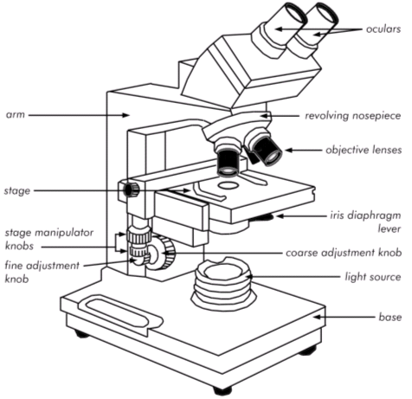
11.
10.
9.
6.
7.

8.
5.
4.
2.
3.
1.

